Swedish Infantry Platoons
1940 to 1945

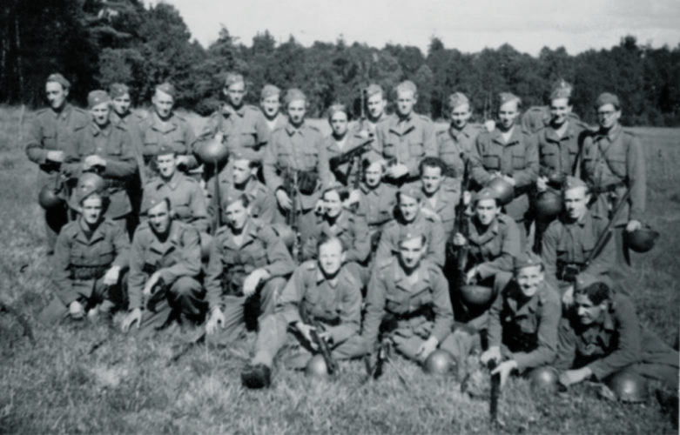

During the hostilities of WW2 the Royal Swedish Army was undergoing a lot of changes and the most significant at the Platoon level was the change introduced in 1943 (the so called 43M organisation). This introduced more power for the Rifle Platoon by equipping the NCOs with SMGs, adding 2 No. Semi-Automatic rifles to each section. Further firepower was also provided by the introduction of a fifth specialist team with a 47mm Mortar Section and an Anti-tank rifleman to each Platoon. In addition a rifleman per section was a designated Sharpshooter and had a scoped rifle.

These changes were gradual and we suggest that the player can choose to play either the 1940 to 1943 or the 1943 to 1945 Rifle Platoon for the 1943 campaign. As an example the number of sub-machine guns and semi-automatic rifles would be aspirational in 1943.

These list allows you to field a normal Rifle Platoon (Skyttepluton) or a Ranger Platoon (Jägarpluton). The latter was more than often be used to do specific recon missions and to distress the enemy. These platoons would most often march onto to the battlefield, with a platoon cart and a horse. Some platoons may be equipped with bikes and some may even be driven to the battlefield in a truck.
Rifle Platoon 1940 to 1943en issued with skis.
Force Rating: Inexperienced -4 /Regular +1 Command Dice: 5
1940 - 1943 Platoon HQ
Löjtnant, Senior Leader, with Pistol
Sergeant (Platoon) , Senior Leader, with 6.5mm m/96 Mauser Rifle
1940 - 1943 Section (Grupp) One
Sergeant, Junior Leader, with 6.5mm m/96 Mauser Rifle
LMG Team  (Kgomgången) | Rifle Team  (Gomgången)
LMG m/37 Automatic Rifle (based on the American BAR), 2 crew  1 Rifleman with 6.5mm m/96 Mauser Rifle | 7 Riflemen with m/96 Mauser Rifle  1 Sub-machine Gunner (SMG, Kpist m/37-39 / m/39)*  * SMG allocation was aspirational.
1940 - 1943 Section (Grupp) Two to Four
Sergeant, Junior Leader, with 6.5mm m/96 Mauser Rifle
LMG Team  (Kgomgången) |  | Rifle Team (Gomgången)
LMG m/37 Automatic Rifle (based on the American BAR), 2 crew  1 Rifleman with 6.5mm m/96 Mauser Rifle |  | 7 Riflemen with m/96 Mauser Rifle
8

Rifle Platoon 1943 to 1945
Force Rating: Inexperienced -3 /Regular +3 Command Dice: 5
1943 - 1945 Platoon HQ
Löjtnant, Senior Leader, with Pistol
Sergeant (Platoon), Senior Leader with SMG (Kpist m/37-39 / m/39)
1943 - 1945 Section (Grupp) One to Two
Sergeant, Junior Leader, with SMG (Kpist m/37-39 / m/39)
LMG Team  (Kgomgången) | Rifle Team (Gomgången)
LMG m/37 Automatic Rifle (based on the American BAR), 2 crew  1 Rifleman with 6.5mm m/96 Mauser Rifle | 1 Sub-machine Gunner (SMG, Kpist m/37-39 / m/39)  2 Riflemen with m/42 Semi-Auto Rifle  2 Riflemen with m/96 Mauser Rifle  1 Marksman with 6.5mm m/96 Mauser Rifle with Telescopic Sight
1943 - 1945 Section (Grupp) Three to Four
Sergeant, Junior Leader, with SMG (Kpist m/37-39 / m/39)
LMG Team  (Kgomgången) | Rfile Team (Gomgången)
LMG m/37 Automatic Rifle (based on the American BAR), 2 crew  1 Rifleman with 6.5mm m/96 Mauser Rifle | 1 Sub-machine Gunner (SMG, Kpist m/37-39 / m/39)  2 Riflemen with m/42 Semi-Auto Rifle  1 Rifleman with m/96 Mauser Rifle  1 Marksman with 6.5mm m/1941 Sniper rifle.
1943 - 1945 Specialist Section
Sergeant, Junior Leader, with 6.5mm m/96 Mauser
Mortar Team | ATR Team
Mortar Operator, m/40 47mm and pistol  Assistant mortar operator, 6.5mm m/96 Mauser Rifle. | Anti-tank gunner with Pansarvärnsgevär m/42  Assistant Anti-tank Gunner, with 6.5mm m/96 Mauser Rifle.

Ranger Platoon 1940 to 1943en

Force Rating: Regular -2 / Elite +2
Command Dice: 5

1940 - 1943 Platoon HQ
Löjtnant, Senior Leader, with Pistol
Sergeant (Platoon) , Senior Leader, with 6.5mm m/96 Mauser Rifle
1940 - 1943 Section (Grupp) One
Sergeant, Junior Leader, with 6.5mm m/96 Mauser Rifle
LMG Team  (Kgomgången) | Rifle Team  (Gomgången)
LMG m/37 Automatic Rifle (based on the American BAR), 2 crew  1 Rifleman with 6.5mm m/96 Mauser Rifle | 7 Riflemen with m/96 Mauser Rifle  1 Sub-machine Gunner (SMG, Kpist m/37-39 / m/39)*  * SMG allocation was aspirational
1940 - 1943 Section (Grupp) Two to Three
Sergeant, Junior Leader, with 6.5mm m/96 Mauser Rifle
LMG Team  (Kgomgången) |  | Rifle Team (Gomgången)
LMG m/37 Automatic Rifle (based on the American BAR), 2 crew  1 Rifleman with 6.5mm m/96 Mauser Rifle |  | 7 Riflemen with m/96 Mauser Rifle

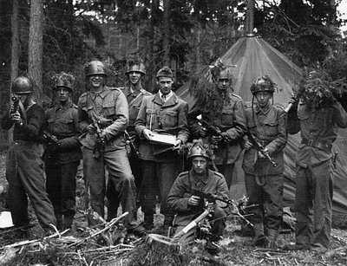
Ranger Platoon 1943 to 1945
Force Rating: Regular +0 / Elite +5
Command Dice: 5

1943 - 1945 Platoon HQ
Löjtnant, Senior Leader, with Pistol
Sergeant (Platoon) , Senior Leader SMG (Kpist m/37-39 / m/39)
1943 - 1945 Section (Grupp) One to Three
Sergeant, Junior Leader, with SMG (Kpist m/37-39 / m/39)
LMG Team  (Kgomgången) | Rifle Team (Gomgången)
LMG m/37 Automatic Rifle (based on the American BAR), 2 crew  1 Rifleman with 6.5mm m/96 Mauser Rifle | 2 Riflemen, with SMG (Kpist m/37-39 / m/39)  2 Riflemen with Semi-Automatic Rifle m/42  1 Riflemen with m/96 Mauser Rifle  1 Marksman with 6.5mm m/1941 Sniper rifle.

Support List
List One
Medical Orderly
Engineering Mine Clearance Team
Engineering Wire Cutting Team
Engineering Demolition Team
Minefield
Barbed Wire
Runner (works as adjutant)
Entrenchment for one Section
Car, no crew
Additional Submachine Gun (mid-1942 forward, and some exceptions)
List Two
Roadblock
ATR Pansarvärnsgevär m/42 (from 1943)
Pre-game Barrage
m/40 47mm mortar team, 3 crew (from 1941)
List Three
MMG Ksp m/1914-29, Ksp m/36 or Ksp m/42, with 5 man team
Sniper Team
List Four
A regular section of Infantry with Junior Leader
Engineer Squad with Junior Leader
Forward observer and 81.4mm Mortar (m/29)
Forward observer and 120mm Mortar (m/41, from 1943)
37mm Bofors m/38 AT gun, 5 crew with Junior Leader
Engineer Flamethrower Team, 3 men (mid-1943 forward)
Pbil m/41 Armoured Car, Junior Leader (from 1941)
Terrängbil m/42 KP Armoured Car, Junior Leader (from 1944)
Pbil m/39 or m/40 Armoured Car, Junior Leader
Strv M/38 Light Tank, with Junior Leader
Strv m/41 Medium Tank with Junior Leader (from 1942)
Strv M/37 Tankette, with MGs, Junior Leader
List Five
75mm m/02-33 Infantry Gun, 5 crew with Junior Leader (m/40 after 1941)
Strv m/42 Medium Tank (75mm) with Junior Leader

Most of the support options on the list will be self-explanatory and their qualities covered by the National Arsenal Table. All tanks and armoured cars come with a Junior Leader. Transport only vehicles, such as the car are simply vehicles which come with no crew. Remember you need to allocate men to drive these.

Satchel Charge

The satchel charge is shown on Table Seven, Hand‐Held Anti‐Tank Weapons. The charge may be used once by any Section on the table when commanded by the Senior Leader commanding the platoon who is, we assume, carrying it with him up to that point.
How the charge works is detailed in Section 9.3.4, Tank Hunters. A maximum of two satchel charges may be selected by a Swedish force.

SWEDISH ARSENAL TABLE

For infantry weapons, consult the Chain of Command rulebook Table Four, the Master Arsenal Table.

SWEDISH ARSENAL TABLE
ARMOURED VEHICLES
VEHICLE | ARMOUR | A.P. | H.E. | SPEED | NOTES
Strv M/37 Tankette¹ | 2 | - | MG | Fast | Low Profile. Small, twin MG
Strv M/38 Light Tank² | 4 | 4 | 6 | Fast | -
PBil m/39 / m/40 Armoured Car³ | 3 | 5 | 4 | Wheeled | -
PBil m/41 Armoured Car⁴ | 3 | 5 | 4 | Wheeled | -
Strv m/41 Medium Tank⁵ | 5 | 5 | 3 | Average | -
Strv m/42 Medium Tank (75mm)⁶ | 5 | 5 | 6 | Average | -
Terrängbil m/42 KP⁷ | 3 | 0 | MG | Fast | 2 crew and 16 passengers
SWEDISH ARSENAL TABLE
ANTI-TANK WEAPONS
ANTI-TANK WEAPONS |  | A.P. |  | H.E.
Pansarvärnsgevär m/42, Recoilless rifle firing solid AP rounds and high explosive. |  | 4 |  | 2
37mm Bofors m/38 AT gun |  | 5 |  | 3
75mm m/02-33 Infantry Gun |  | 7 |  | -

Stats based on similar vehicles from other lists from Too Fat Lardies rulebook or lists on their webpage.
1. Based on Polish TKS Tankette with MGs (Polish 1939 list)
2. Based on PzII (German 1940 list)
3. Based on the Russian BA-10 (Russian 1939-40 list)
4. Based on the Russian BA-10 (Russian 1939-40 list)
5. Based on the Panzer 38(t) (German 1940 list)
6. Based on the Panzer 38(t), A.P. and H.E. based on Early PzVI (German 1940 list)
7. Based on the M3 (American list in Chain of Command Rulebook) - only used by the mechanized infantry attached to the tank units.

