Swedish Infantry Platoons
1939 to 1945

During the hostilities of WW2 the Royal Swedish Army was undergoing a lot of changes and the most significant at the Platoon level was the change introduced in 1943 (the so called 43M org.). This introduced more fire power for the Rifle Platoon by equipping the NCOs with SMGs, adding 2 No. Semi-Automatic rifles to each section, introducing a 47mm Mortar Section and an Anti-tank rifle to each Platoon) and at the same time reducing the size of the overall platoon.

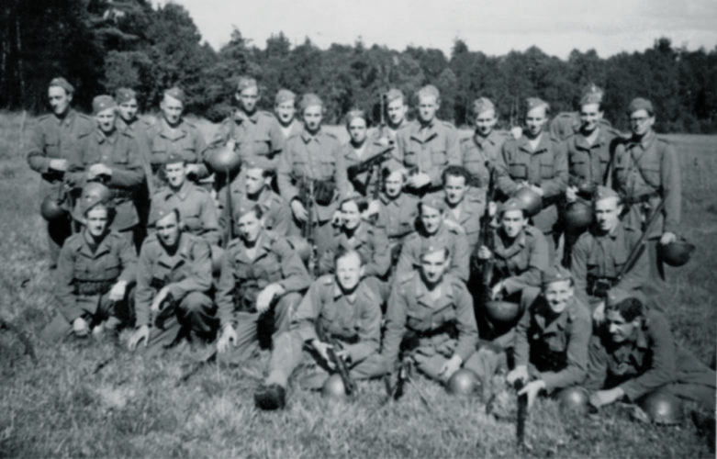
This list allows you to field a normal Rifle Platoon (Skyttepluton) or a Scout Platoon (Jägarpluton), there was initially a Scout Platoon per company but in the 43M re-organisation one Scout Platoon per was allocated to each battalion.

Platoon 1939 to 1943en issued with skis.
Force Rating: Inexperienced -4 /Regular +1 / Elite +9 (Rifle Platoon Regular or Inexperienced, Scout Platoon Regular or Elite )
Command Dice:

1940 - 1943 Platoon HQ
Löjtnant, Senior Leader, with Pistol
Sergeant (Platon) , Senior Leader, with 6.5mm m/96 Mauser Rifle
1940 - 1943 Section One to Four
Sergeant, Junior Leader, with 6.5mm m/96 Mauser Rifle
Korpral, with 6.5mm m/96 Mauser Rifle (count as rifle man)
Machine Gunner with m/37 Automatic Rifle (based on the American BAR)
9 Riflemen with 6.5mm m/96 Mauser Rifle

Rifle Platoon 1943 to 1945
Force Rating: Inexperienced -3 /Regular +3 / Elite +12 (Rifle Platoon Regular or Inexperienced, Scout Platoon Regular or Elite )
Command Dice:

1943 - 1945 Platoon HQ
Löjtnant, Senior Leader, with Pistol
Sergeant (Platoon) , SMG (Kpist m/37-39 / m/39)
ATR Pansarvärnsgevär m/42, no crew
1943 - 1945 Section One to Four
Sergeant, Junior Leader, with SMG
Korpral, with SMG (count as SMG gunner)
Machine Gunner with m/37 Automatic Rifle (based on the American BAR)
5 Riflemen with 6.5mm m/96 Mauser Rifle
2 Riflemen with Semi-Automatic Rifle m/42

1943 - 1945 Mortar Section
m/40 47mm mortar team, 3 crew

Support List
List One
Medical Orderly
Engineering Mine Clearance Team
Engineering Wire Cutting Team
Engineering Demolition Team
Minefield
Barbed Wire
Runner (works as adjutant)
Entrenchment for one Section
Car, no crew
Submachine Gun (mid-1942 forward)
List Two
Roadblock
ATR Pansarvärnsgevär m/42 (from 1943)
Pre-game Barrage
m/40 47mm mortar team, 3 crew (1941 forward)
List Three
MMG Ksp m/1914-29, Ksp m/36 or Ksp m/42, with 5 man team
Sniper Team
List Four
A regular section of Infantry with Junior Leader
Engineer Squad with Junior Leader
Forward observer and 81.4mm Mortar (m/29)
Forward observer and 120mm Mortar (m/41, from 1943)
37mm Bofors m/38 AT gun, 5 crew with Junior Leader
Engineer Flamethrower Team, 3 men (mid-1943 forward)
Pbil m/41 Armoured Car, Junior Leader (from 1941)
Pbil m/39 or m/40 Armoured Car, Junior Leader
Strv m/41 Medium Tank with Junior Leader (from 1942)
Strv M/37 Tankette, with MGs, Junior Leader
List Five
75mm m/02-33 Infantry Gun, 5 crew with Junior Leader (m/40 after 1941)
Strv M/38 Light Tank, with Junior Leader
Strv m/42 Medium Tank (75mm) with Junior Leader

Most of these support options on the list will be self-explanatory and their qualities covered by the National Arsenal Table. All tanks and armoured cars come with a Junior Leader. Transport only vehicles, such as the car are simply vehicles which come with no crew. Remember you need to allocate men to drive these.

Satchel Charge

The satchel charge is shown on Table Seven, Hand‐Held Anti‐Tank Weapons. The charge may be used once by any Section on the table when commanded by the Senior Leader commanding the platoon who is, we assume, carrying it with him up to that point.
How the charge works is detailed in Section 9.3.4, Tank Hunters. A maximum of two satchel charges may be selected by a Swedish force.

47mm Mortar Team

I do not know how it was used in combat (i.e. did they use smoke?).

Note: Handgrenades of german stick design

SWEDISH ARSENAL TABLE

For infantry weapons, consult the Chain of Command rulebook Table Four, the Master Arsenal Table.

SWEDISH ARSENAL TABLE
ARMOURED VEHICLES
VEHICLE | ARMOUR | A.P. | H.E. | SPEED | NOTES
Strv M/37 Tankette¹ | 2 | - | MG | Fast | Low Profile. Small, twin MG
Strv M/38 Light Tank² | 4 | 4 | 6 | Fast | -
PBil m/39 / m/40 Armoured Car³ | 3 | 5 | 4 | Wheeled | -
PBil m/41 Armoured Car⁴ | 3 | 5 | 4 | Wheeled | -
Strv m/41 Medium Tank⁵ | 5 | 5 | 3 | Average | -
Strv m/42 Medium Tank (75mm)⁶ | 5 | 5 | 6 | Average | -
Terrängbil m/42 KP⁷ | 3 | 0 | MG | Fast | -
SWEDISH ARSENAL TABLE
ANTI-TANK WEAPONS
ANTI-TANK WEAPONS |  | A.P. |  | H.E.
Pansarvärnsgevär m/42, Recoiless rifle firing solid AP rounds and high explosive. |  | 4 |  | 2
37mm Bofors m/38 AT gun |  | 5 |  | 3
75mm m/02-33 Infantry Gun |  | 7 |  | -

Stats based on similar vehicles from other lists from Too Fat Lardies rulebook or lists on their webpage.
1. Based on Polish TKS Tankette with MGs (Polish 1939 list)
2. Based on PzII (German 1940 list)
3. Based on the Russian BA-10 (Russian 1939-40 list)
4. Based on the Russian BA-10 (Russian 1939-40 list)
5. Based on the Panzer 38(t) (German 1940 list)
6. Based on the Panzer 38(t), A.P. and H.E. based on Early PzVI (German 1940 list)
7. Based on the M3 (American list in Chain of Command Rulebook)

